

**Project Report on**

**Online Movies Booking**

**System**

**B.C.A. Semester – 5**

**Academic Year 2024-25**

**Developed By:**

|  |  |  |
| --- | --- | --- |
| No. | Name’s | Enrollment Number |
| 1. | Hadani Vishnu | 00330322671 |
| 2. | Chudasama Vishal | 00330322650 |
| 3. | Shah Rajkumar | 00330322756 |

Index

|  |  |  |
| --- | --- | --- |
| **No.** | **Title** | **Page No.** |
| 1. | Preface | 3 |
| 2. | Acknowledgment | 4 |
| 3. | Project Profile | 5 |
| 4. | Introduction Of Project | 6 |
| 5. | System Requirement | 7 |
| 6. | Front-End & Back-End | 8 |
| 7. | System Analysis | 13 |
| 8. | Feasibility Study | 14 |
| 9. | Functional Requirement | 17 |
| 10. | Non-Functional Requirement | 18 |
| 11. | Project Scheduling | 19 |
| 12. | Data Flow Diagram | 21 |
| 13. | Flow Chart | 25 |
| 14. | ER-Diagram | 32 |
| 15. | Data Directory | 34 |
| 16. | Screenshot | 38 |
| 17. | System Testing | 44 |
| 18. | Implementation and Maintenance | 45 |
| 19. | Limitation of the Project | 47 |
| 20. | Bibliography | 48 |

Preface

Theory of any subject is important but without its practice it becomes useless particularly for the computer student. A computer student can’t become a perfect man of technologist without practical understanding of branch. Hence this visiting provides golden opportunity for all computer students.

To compete in today’s competitive market the strategies to compete in today’s competitive market the strategies you design and use should resolve around the current market and area.

We can also say, "Experience is the best teacher" so our project is one kind of Experience, the part of our life. Through the project we have learnt Good, Real and Practical application.

The project training in the B.C.A of the course gives us the exposure to real world. The aim of the project training, by understanding a project, is to have practical experience of the real world. It also clears the picture of practical field to prompt the student to develop their qualities talents, etc.

So that we can extend our view about the implication of the theoretical knowledge in the practical field, we had the opportunity for the same at various field.

Acknowledgement

We are very thankful to the project coordinator, Prof. Bharmal Mohammad of Smt. J. J. Kundalia Commerce College, who has provided us with a lot of support and guidance from the beginning to the end of the project development.

A work of this nature would not have been possible without the encouragement and meticulous attention received from him. The faculties have also played a vital role in building up our project website. Under their guidance and training, it became much easier to develop the project.

A work of this nature would not have been possible without the encouragement and meticulous attention received from him. Prof. Bharmal Mohammad's constant help, numerous suggestions, thoughtful tips, and deep interest in this system have enabled us to complete this work very easily and as nicely as it would not have been otherwise.

This project, developed by Chudasama Vishal, Hadani Vishnu, and Shah Rajkumar, is a testament to the collaborative effort and guidance we received.

Project Profile

Project Name : Online Movies Booking System

Front-End : HTML, CSS, JavaScript, Jquery, Ajax

Back-End : PHP, MySQL

Documentation Tool : Microsoft Word 2016

Operating System : Windows 11

Web Server : Apache

Web Browser : Google Chrome

Guided By : Mohammad Bharmal

Submitted To : Smt. J. J. Kundalia Commerce College

Project Duration : 2 Months

Academic Year : 2024-25

Team Members : 1. Chudasama Vishal B.

2. Hadani Vishnu R.

3. Shah Rajkumar N.

Introduction of Project

* **Purpose:**

This project titled “Online Movie Booking System” is designed using HTML, CSS, JavaScript (including jQuery and Ajax) for the client side, and PHP with MySQL for the server side. This combination helps in understanding different technologies and their integration.

This project is intended to facilitate users in booking movie tickets online. The website is highly useful for users to view the latest movies, check showtimes, select seats, and make payments. Additionally, users can view their booking history, update their profiles, and cancel bookings if needed.

From the admin's perspective, the system provides comprehensive tools to manage movie listings, view user bookings, and update movie information. The admin can add new movies, delete existing ones, and see detailed booking histories of all users.

* **Objective:**

The Online Movie Booking System allows users to view the latest movies and showtimes currently available, select their preferred showtime and seats, and make payments to book tickets. Users can also partially pay for their tickets if the feature is enabled.

The system provides an intuitive interface for users to manage their profiles and booking history, enhancing the overall movie-going experience by offering convenience and ease of use. For administrators, the system offers robust features to manage movie data and user bookings efficiently.

System Requirement

* **Hardware Requirements:**

|  |  |
| --- | --- |
| **Category** | **Requirements** |
| Processes | P-4 2.4 GHz |
| Ram | 128 MB DDR |
| Hard Disk / SSD | 40 GB |
| Others I/O Devices | 14” Color Monitor |
| Network Devices | Network Adapter |
| System Type | 32-bit Operating System |

* **Software Requirements:**

|  |  |
| --- | --- |
| **Category** | **Requirements** |
| Windows XP or above | Used to run browser |
| Web Browser | Used to display website |

Front-End Tools

* **HTML: -**

It isn't a programming language. Html is exactly what it claims to be a markup language, you use HTML to markup a text document, just as you would if you were an editor with a red pencil.

The HTML is a simple markup language used to create hypertext document that are platform independent. HTML documents are SGML documents with generic semantics that are appropriate for representing information from a wide range of domains.

HTML markup can represent hypertext news, email, documentation, hypermedia, menus of options, database query result and hypertext views of existing bodies of information.

HTML has been in used by the WWW global information initiative since 1990. This specification roughly corresponds to the capabilities of HTML in common use prior to June 1994.

* **CSS: -**

If cascading style sheets can be a bit intimidating at first glance, especially if you are new to webpage coding. It might be best to avoiding into style until you have done a few pages and are comfortable handling basic html.

In additional to offering many options many options not available in standard html, style can save you time, increase accuracy, and improve uniformity of appearance throughout your Web pages.

* **Bootstrap: -**

Bootstrap is a powerful front-end framework used to design responsive and mobile-first websites. Developed by Twitter, Bootstrap simplifies web development with its pre-built CSS and JavaScript components. It provides a robust grid system, responsive design features, and a wide array of UI components like buttons, forms, and navigation bars. By leveraging Bootstrap, developers can create modern, consistent, and visually appealing web applications quickly and efficiently.

One of Bootstrap's key strengths lies in its ease of use and customization options. Developers can easily modify the default styles, colors, and layouts to suit their project requirements, using its extensive documentation and examples. This flexibility, coupled with its wide adoption and active community support, makes Bootstrap a preferred choice for building responsive websites across different devices and screen sizes.

* **JavaScript: -**
* What is JavaScript?

JavaScript is most commonly used as a client-side scripting language. This means that JavaScript code is written into an HTML page. When a user requests an HTML page with JavaScript in it, the script is sent to the browser and it's up to the browser to do something with it.

**-** JavaScript is a programming language for use in HTML pages.

**-** Invented in 1995 at Netscape Corporation (Live Script).

**-** JavaScript programs are run by an interpreter built into the user's web browser.

* What can JavaScript Do?

**-** JavaScript can dynamically modify an HTML page.

**-** JavaScript can react to user input.

**-** JavaScript can validate user input.

**-** JavaScript is a full-featured programming language.

**-** JavaScript user interaction does not require any communication with the server.

* **JQuery**: -

jQuery is a fast, lightweight, and feature-rich JavaScript library designed to simplify HTML document traversal, event handling, and animation. It provides an easy-to-use API that works across a multitude of browsers, enabling developers to write less code and accomplish more.

With its extensive plugins and community support, jQuery remains a popular choice for adding interactive and dynamic elements to web pages, enhancing user experience with minimal effort.

* **Ajax**: -

Ajax (Asynchronous JavaScript and XML) is a technique used in web development to create asynchronous web applications. It allows web pages to update content dynamically without requiring a full page reload, enhancing the user experience by making web applications faster and more responsive.

By sending and retrieving data from a server asynchronously in the background, Ajax enables the seamless integration of server-side data with client-side scripts, resulting in more interactive and efficient web applications.

Back-End Tools

* **PHP**: -

The full for of pup is "Hypertext preprocessor". Its original name was "Personal home page". PHP is a widely- used open-source general-purpose scripting language that is especially suited for web development and can be embedded into HTML.

PHP is mainly focused on server-side scripting, so you can do anything any other CGI program can do, such as collect from data, generate dynamic page content, or send and receive cookies.

With PHP you are not limited to output HTML. PHP's abilities include outputting images, PDF file and even flash movies generated on the fly. You can also output easily and text, such as XHTML and any other XML file. PHP can auto generate these files, and save them in the file system, instead of printing it out, forming a server-side cache for your dynamic content.

* **MYSQL**: -

MySQL is an open-source relational database management system (RDBMS) widely used for web applications and data storage. Developed by Oracle Corporation, it is known for its reliability, scalability, and ease of use, making it a popular choice among developers and businesses alike. MySQL supports standard SQL (Structured Query Language) and offers robust transactional support, ensuring data integrity and consistency.

One of MySQL's key advantages is its flexibility and compatibility with various platforms, including Windows, Linux, and macOS. It integrates seamlessly with popular web technologies like PHP, Apache, and Nginx, enabling the development of dynamic and data-driven websites. MySQL's efficient storage and retrieval capabilities make it ideal for handling large volumes of data in applications ranging from simple blogs to complex e-commerce sites.

In addition to its strong community support, MySQL offers extensive documentation and a range of tools for database management and optimization. With features like replication, clustering, and partitioning, MySQL provides high availability and performance for mission-critical applications. Whether for small projects or large enterprise solutions, MySQL remains a trusted and versatile database solution.

System Analysis

System analysis is an essential part of any project management. It involves understanding and specifying in detail what an information system should do. Surprisingly, it’s an area that often receives far too little attention.

* **Users:**

Users want to see the latest movies, showtimes, and cinema information, and they desire an easy and convenient way to book tickets online. The system is designed to meet these needs by offering a user-friendly interface where users can browse movies, select showtimes, choose their seats, and make payments seamlessly. Additionally, users can view their booking history, update their profiles, and cancel bookings if necessary.

* **Admin:**

Admin has full authority over the entire site. The admin has the rights to add, edit, or delete movie listings, manage showtimes, and update user information. The admin can also view detailed booking histories of all users, manage user profiles, and ensure the smooth operation of the system.

Feasibility Study

Before designing and implementing the proposed system, it was imperative to ensure that the proposed system was practical for an online movie booking system. The aim of the feasibility study was to investigate the information needs of the users and determine if the choice of system being proposed was a viable entertainment proposition. Avison and Shah feel it is a "crucial stage in the information systems development life cycle" as "it is the last stage before a considerable number of resources are invested in a project, and therefore needs to be handled very carefully".

* **Technical:**

This section focuses on the question "Does current technology support the proposed system?". It deals with technology issues such as hardware, software, and security. It is important that the chosen technology meets the requirements of the user, and the technical decisions take into account any restrictions on the development.

In this project, PHP and MySQL were selected as the technology stack for implementing the system. The proposed system is feasible as the database can cope with the storage requirements when holding the movie details while the site can manage a number of different daily transactions passing through the system. This is important as it will ensure that any querying or modifications to the database will be done efficiently via the graphical user interface, therefore preventing problems for the user.

* **Economical:**

This section concentrates on "whether a proposed information system is financially affordable and if it is going to lead to economic benefits". Heathcoat states that "if the benefits do not outweigh the costs, then it is not worth going ahead with".

In this instance, a cost-benefit analysis was used to investigate the costs of the proposed system. Website costs, such as the use of PHP and MySQL, are minimal as both are open source. The analyst designing, developing, and testing the system will not be charging any fees as the proposed system is part of their final year project. These minimal costs will be extremely beneficial to the user as they will gain a system that efficiently handles movie bookings and provides a smooth user experience without the need for any paperwork.

* **Schedule:**

Schedule feasibility is considered regarding the time duration of the project. There is no value, or reduced value, if it takes too long to complete.

It is unnecessary to proceed with the project if it cannot be completed within a particular time frame. If it takes too long, it will impact economic feasibility and could lead to project failure.

Additionally, if the project takes more time to complete, the cost of the project will grow day by day.

* **Operational:**

Users get information about movies and showtimes, and we aim to help by providing an easy and intuitive booking process. We strive to make the site user-friendly and efficient, minimizing loading times and ensuring a smooth experience for the users.

The system will be easy to use for all age groups and will not take long to learn and access. It will provide a seamless experience from browsing movies to booking tickets and making payments.

Functional Requirements

The functional requirements specification documents the operations and activities that the system must be able to perform.

The Online Movie Booking System provides various functionalities to users, including:

* Viewing the latest movies, showtimes, and cinema information.
* Booking movie tickets by selecting showtimes and choosing seats.
* Making payments using different methods such as cards and UPI (QR code).
* Viewing and updating user profiles.
* Checking booking history and canceling bookings if necessary.
* Resetting forgotten passwords using security questions and answers.

Non-Functional Requirements

Non-functional requirements describe how the system works, while functional requirements describe what the system should do. Although non-functional requirements are often considered less critical, they are essential for ensuring the system's overall performance and user satisfaction.

The non-functional requirements for the Online Movie Booking System include:

* **Security:** Users must be forced to change their password if it has expired. Passwords can be reset using security questions and answers.
* **Access Control:** Only the system's data administrator can change access permissions for system data. Security measures ensure that at least 20% of processor capacity and storage space are available at peak load periods.
* **Performance:** The system must handle user actions efficiently, with the ability to process a minimum of 10 bookings per second during peak times.
* **Usability:** The system must be user-friendly, easy to navigate, and accessible for all age groups, ensuring a seamless experience from browsing movies to making payments.
* **Reliability:** The system must be robust, with minimal downtime, ensuring users can access the platform and complete transactions without issues.

Project Scheduling

* **Gantt chart: -**

A Gantt chart is a type of bar chart, developed by Henry Gantt, which illustrates a project schedule. Gantt charts illustrate the start and finish dates of the terminal elements and summary elements comprise the work breakdown structure of the projects.

Some Gantt charts also show current schedule using percent- complete shadings. Gantt chart is also known as a Timeline chart.

* **Pert chart: -**

A PERT chart is a project management tool used to schedule, organize, and coordinate tasks within a project. PERT stands for Program Evaluation Review Technique, a methodology developed by the U.S. Navy in the 1950s to manage the Polaris submarine missile program.

|  |  |  |
| --- | --- | --- |
| Early Start | Duration | Early Finish |
| Activity | | |
| Late Start | Stack | Late Finish |

|  |  |  |
| --- | --- | --- |
| 0 | 10 | 10 |
| Feasibility Study | | |
| 0 | 0 | 10 |

|  |  |  |
| --- | --- | --- |
| 10 | 7 | 17 |
| System Analysis | | |
| 10 | 0 | 17 |

|  |  |  |
| --- | --- | --- |
| 17 | 13 | 30 |
| System Design | | |
| 17 | 0 | 30 |

|  |  |  |
| --- | --- | --- |
| 30 | 53 | 83 |
| Coding | | |
| 10 | 0 | 17 |

|  |  |  |
| --- | --- | --- |
| 83 | 3 | 86 |
| Testing | | |
| 83 | 0 | 86 |

|  |  |  |
| --- | --- | --- |
| 86 | 4 | 90 |
| Implementation | | |
| 30 | 0 | 83 |

Data-Flow Diagram

A Data Flow Diagram (DFD) is a graphical representation of the flow of data through an information system, illustrating its process aspects. It serves as a preliminary step to provide an overview of the system's functionality before detailed design. The DFD components include:

* **External Entity (Terminator):**

An external entity refers to a person, an institution or a department that is outside of the system being modelled. It is a thing where data originates (data source) and is usually a final destination (data sink). As such an entity is often referred to as a terminator.

* **Process (Presentation): -**

A Process is represented graphically as a circle Rectangle with rounded edge.

* **Data Flow: -**

It is used to describe the more event of data or physical material from one part of the system to another part.

* **Data Store: -**

It is used to model a collection of data packets at rest (1) Files (2) Tapes (3) Punched cards etc.

* **Output: -**

This box represents data production during human interaction computer output data generated by system.

* **Context Level Diagram: -**
* **DFD 1st Level Diagram (Admin): -**

Logout

Date

Status

view

Booking History

Select

Admin

Login

View All Movies

Insert

Add Movie

Delete

Delete Movie

All Booked

* **DFD 1st Level Diagram (Client): -**

Register

View Profile

All movies

Client

Login

Information

Update

Status

Booking History

Cancel

Change password

Logout

A flowchart is a visual representation of a process or workflow, commonly used in various fields such as software development, business analysis, and project management. It uses standardized symbols and connectors to depict the sequence of steps and decisions involved in completing a task or achieving a goal. Flowcharts are invaluable tools for clarifying complex processes, identifying bottlenecks, and improving efficiency.

Flow Chart

**The key elements of a flowchart include:**

* **Symbols**: Each step or action in a process is represented by a specific symbol, such as a rectangle for a process step, a diamond for a decision point, or an oval for the start and end points of the process.
* **Arrows and Lines**: These connectors show the flow of control or data between the symbols, indicating the sequence of actions or decisions.
* **Decision Points**: Flowcharts use diamonds to denote decision points where different actions or paths can be taken based on conditions or inputs.

**Flowcharts offer several benefits:**

* **Clarity and Understanding**: They provide a clear visual representation of complex processes, making it easier for stakeholders to understand how tasks are performed and how data flows within a system.
* **Communication Tool**: Flowcharts serve as effective communication tools, enabling teams to discuss, analyze, and improve processes collaboratively.
* **Process Improvement**: By visually mapping out processes, flowcharts facilitate identification of inefficiencies, redundancies, or opportunities for optimization, leading to improved workflows and resource utilization.
* **Program Flowchart Shapes: -**

|  |  |  |
| --- | --- | --- |
| Symbol | Name | Function |
|  | Start/end | An Oval represents a start or end point |
|  | Arrows | A line is a connector that shows relationships between the representative shapes |
|  | Input/Output | A parallelogram represents input or output |
|  | Process | A rectangle represents a process |
|  | Decision | A diamond indicates a decision |

* **Sign up:**

Home

Execute Query

Check Input

Input data

* **User and Admin Login:**

Enter Email & Password

Check Email & Password

Home

* **Insert Record: -**

Input data

Display Error

Check Input

Input Record

* **Update Record: -**

Display Old Record

Input New Record

Display Error

Check Input

NO

Update Record

* **Delete record:**

Display data

Execute Query

No

YES

Record Deleted

|  |
| --- |
|  |
|  |  |

E-R Diagram is one of the better ways to communicate Different of a component of a system. They are also too easy to Understand by everyone. They offer an overview of the entire System. An ER-Diagram is graphical method of representing entity classes, attributes and relationship. An ER-Diagram uses six basics Symbols.

E-R Diagram

* **Admin Diagram**

Login

Admin (Dashboard)

* **User Diagram**

Login or Register

User (Index)

Data Directory

A data dictionary is a catalo-a-repository-of the elements in a system as the name suggests, these elements centre on data and the way they are structured to meet users’ requirements and organization needs in a data dictionary you will find a list of all elements composing the data flowing through a system.

**Database Name: v8**

|  |  |  |
| --- | --- | --- |
| No. | Table Name | Description |
| 1 | admin | Store the info about Admin |
| 2 | bookings | Store the all bookings information |
| 3 | cinema | Store the info about all cinema |
| 4 | movies | Store the info about all movies |
| 5 | seats | Store the info about seats as cinema |
| 6 | times | Store the info about show time |
| 7 | users | Store the info about User Login |

***Tables Information: -***

* **admin, users : -**

|  |  |  |  |  |
| --- | --- | --- | --- | --- |
| Key | Name | Type | Size | Constraints |
| 1 | id | int | 11 | PRIMARY KEY, AUTO_INCREMENT |
| 2 | name | varchar | 255 | NOT NULL |
| 3 | email | varchar | 255 | NOT NULL |
| 4 | password | varchar | 255 | NOT NULL |
| 5 | mobile_number | number | 10 | NOT NULL |
| 6 | security_question | varchar | 255 | NOT NULL |
| 7 | answer | varchar | 255 | NOT NULL |
| 8 | date | timestamp | -- | DEFAULT current_timestamp() |
| 9 | modify_date | timestamp | -- | ON UPDATE current_timestamp() |

* **cinema : -**

|  |  |  |  |  |
| --- | --- | --- | --- | --- |
| Key | Name | Type | Size | Constraints |
| 1 | id | int | 11 | PRIMARY KEY, AUTO_INCREMENT |
| 2 | name | varchar | 255 | NOT NULL |
| 3 | location | varchar | 255 | NOT NULL |
| 4 | facilities | text | -- | NULL |
| 5 | created_at | timestamp | -- | DEFAULT current_timestamp() |
| 6 | update_at | timestamp | -- | ON UPDATE current_timestamp() |
| 7 | price_level | varchar | 20 | NOT NULL |

* **movies :-**

|  |  |  |  |  |
| --- | --- | --- | --- | --- |
| Key | Name | Type | Size | Constraints |
| 1 | id | int | 11 | PRIMARY KEY, AUTO_INCREMENT |
| 2 | title | varchar | 255 | NOT NULL |
| 3 | genre | varchar | 100 | NOT NULL |
| 4 | duration | varchar | 20 | NOT NULL |
| 5 | rating | varchar | 10 | NOT NULL |
| 6 | language | varchar | 80 | NOT NULL |
| 7 | director | varchar | 50 | NOT NULL |
| 8 | image_location | varchar | 255 | NOT NULL |
| 9 | discription | text | -- | NOT NULL |
| 10 | release_date | varchar | 20 | NOT NULL |
| 11 | created_at | timestamp | -- | DEFAULT current_timestamp() |
| 12 | update_at | timestamp | -- | ON UPDATE current_timestamp() |
| 13 | movie_price | int | 4 | NOT NULL |

* seats : -

|  |  |  |  |  |
| --- | --- | --- | --- | --- |
| Key | Name | Type | Size | Constraints |
| 1 | id | int | 11 | PRIMARY KEY, AUTO_INCREMENT |
| 2 | cinema_id | int | 11 | FOREIGN KEY |
| 3 | total_seats | int | 11 | NOT NULL |
| 4 | seat_structure | text | -- | DEFAULT NULL |
| 5 | no_seat | text | -- | DEFAULT NULL |
| 6 | available_seats | int | 11 | DEFAULT NULL |
| 7 | booked_seats_name | text | -- | DEFAULT NULL |
| 8 | created_at | timestamp | -- | DEFAULT current_timestamp() |
| 9 | updated_at | timestamp | -- | ON UPDATE current_timestamp() |

* times : -

|  |  |  |  |  |
| --- | --- | --- | --- | --- |
| Key | Name | Type | Size | Constraints |
| 1 | id | int | 11 | PRIMARY KEY, AUTO_INCREMENT |
| 2 | cinema_id | int | 11 | FOREIGN KEY |
| 3 | show_time | time | 11 | NOT NULL |
| 4 | show_date | date | -- | NOT NULL |
| 5 | created_at | timestamp | -- | DEFAULT current_timestamp() |
| 6 | updated_at | timestamp | -- | ON UPDATE current_timestamp() |

* **bookings : -**

|  |  |  |  |  |
| --- | --- | --- | --- | --- |
| Key | Name | Type | Size | Constraints |
| 1 | id | int | 11 | PRIMARY KEY, AUTO_INCREMENT |
| 2 | user_name | varchar | 200 | NOT NULL |
| 3 | movies_title | varchar | 250 | NOT NULL |
| 4 | cinema_name | varchar | 255 | NOT NULL |
| 5 | number_of_seats | int | 5 | NOT NULL |
| 6 | total_price | decimal | 10,2 | NOT NULL |
| 7 | booking_date | timestamp | -- | DEFAULT current_timestamp() |
| 8 | update_at | timestamp | -- | ON UPDATE current_timestamp() |
| 9 | booked_seats_name | text | -- | NOT NULL |
| 10 | status | varchar | 20 | NOT NULL |

Screenshots

***Client Side :-***

User Register page:

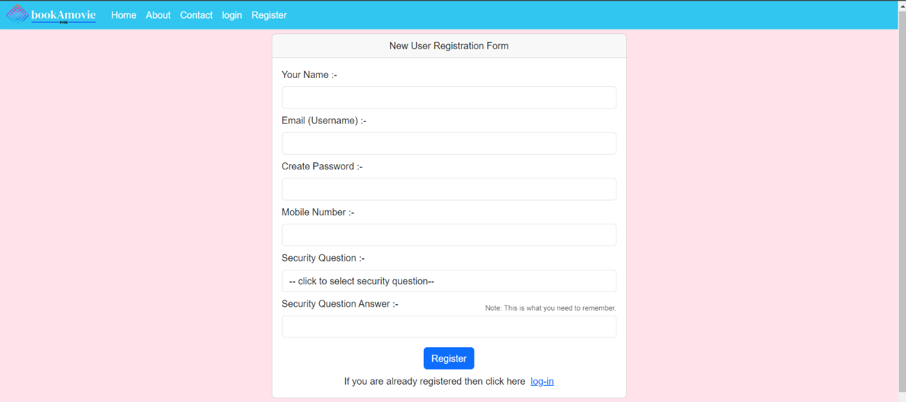

User Login page:

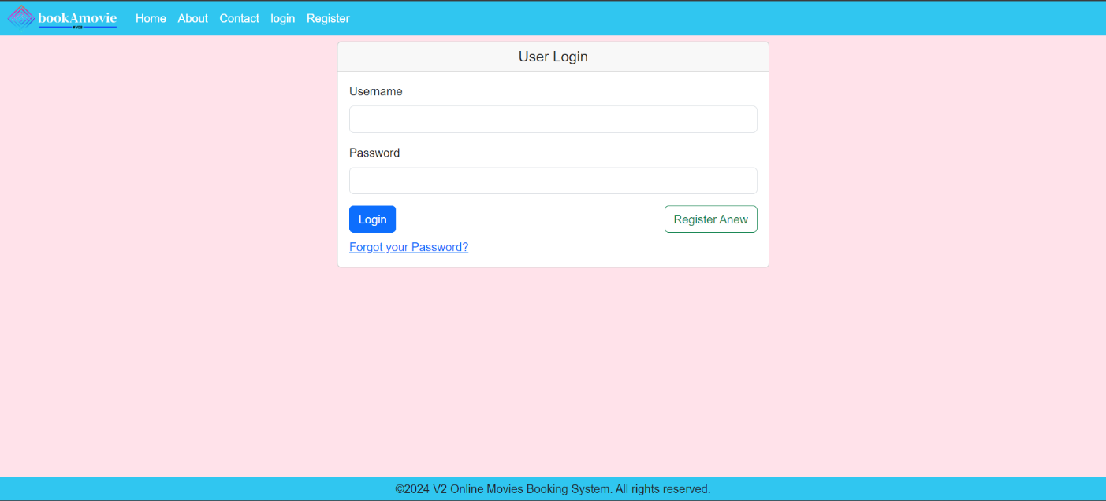

Change Password:

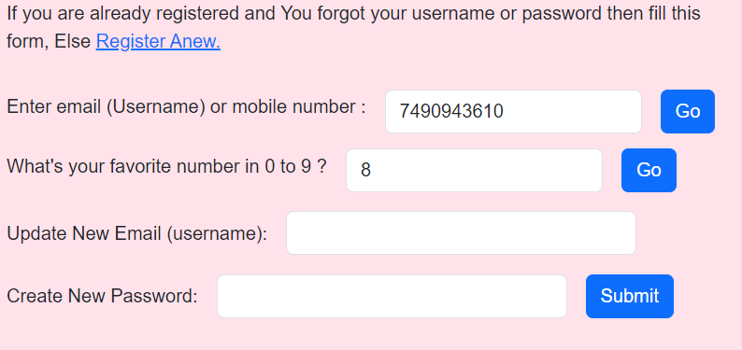

Home(index):

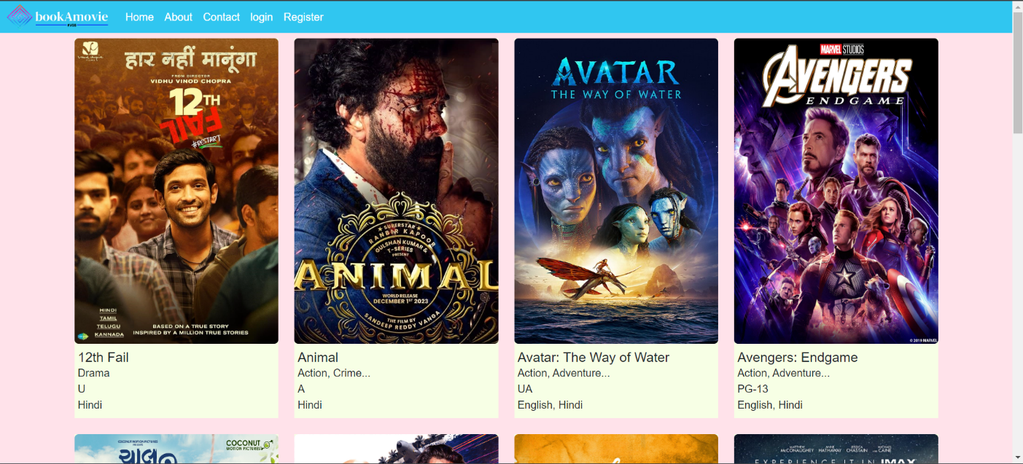

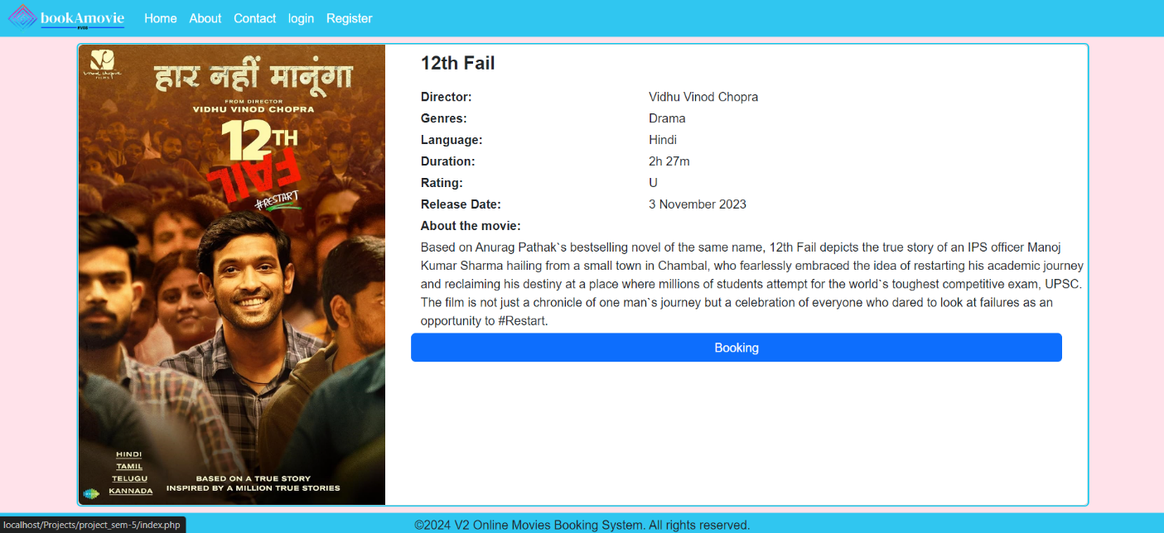Movie information page:

Select Date and Time Page:

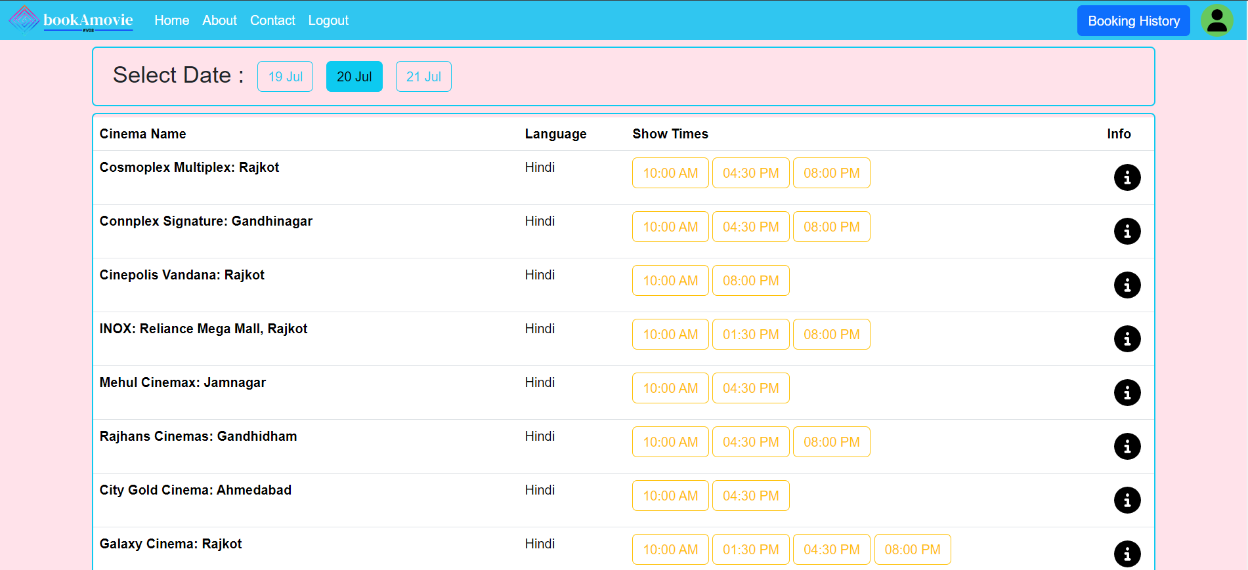

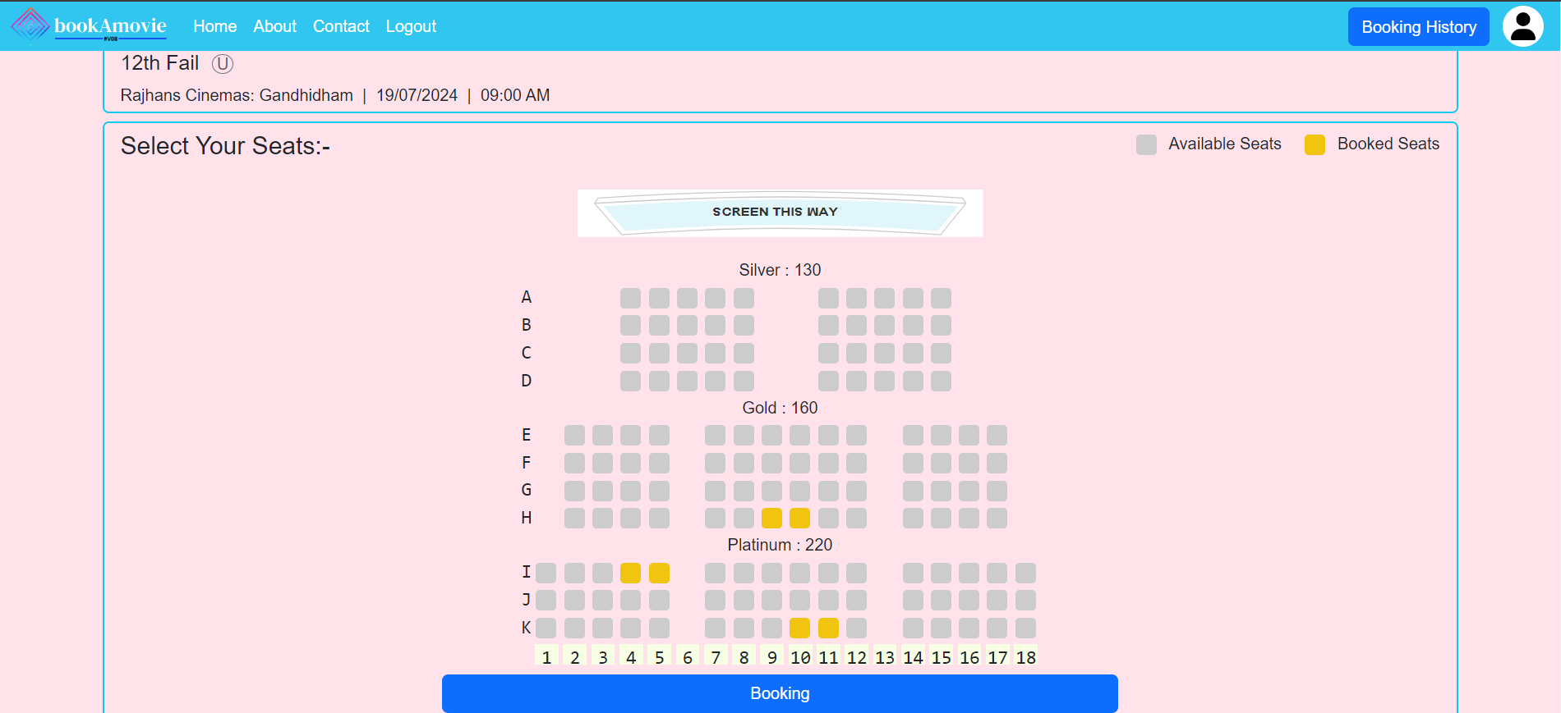Seats Layout and Selection Page:

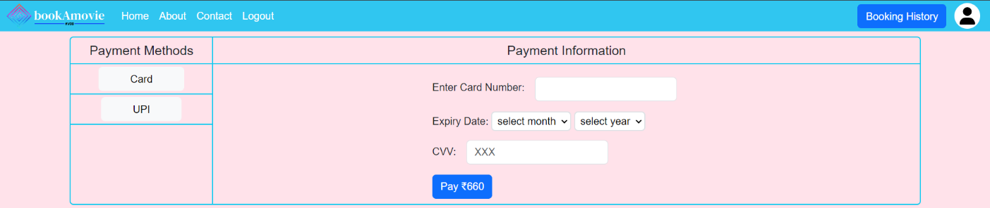Payment Page:

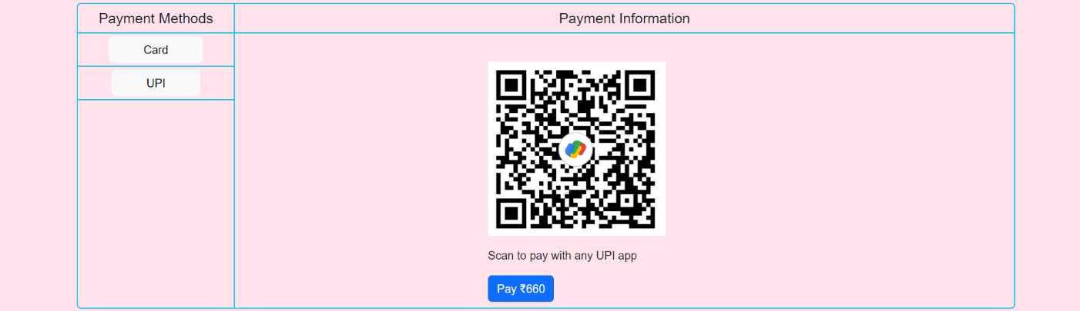

Ticket Layout Page: 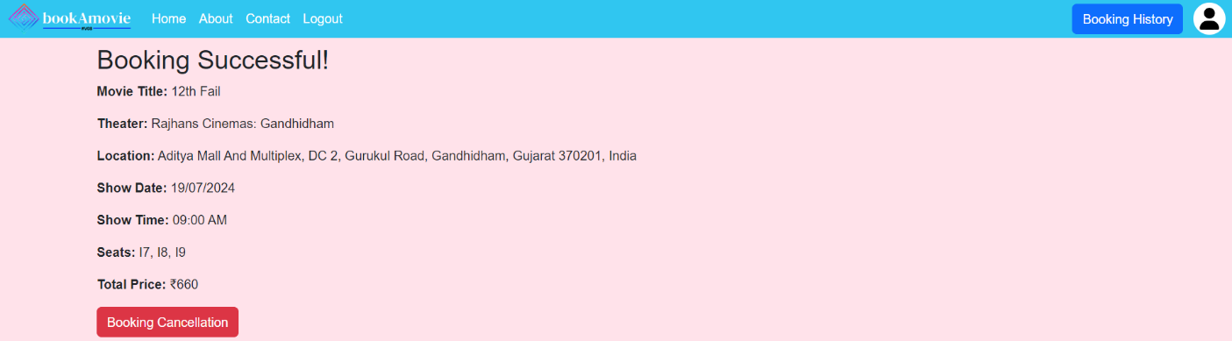

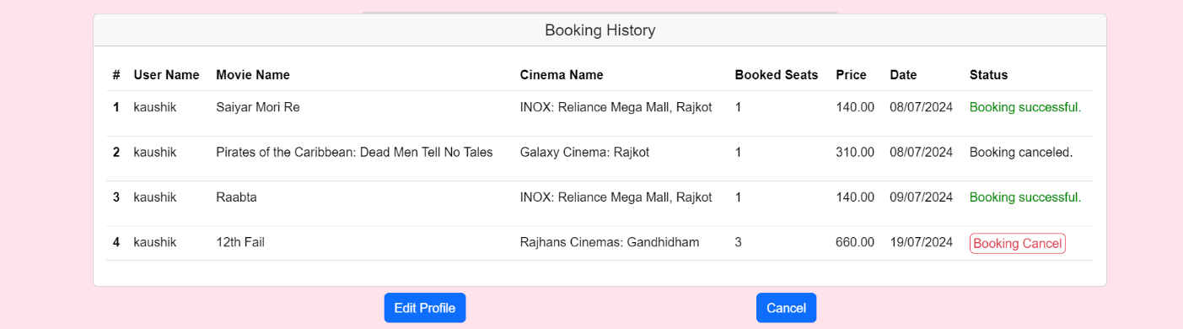Booking History Page:

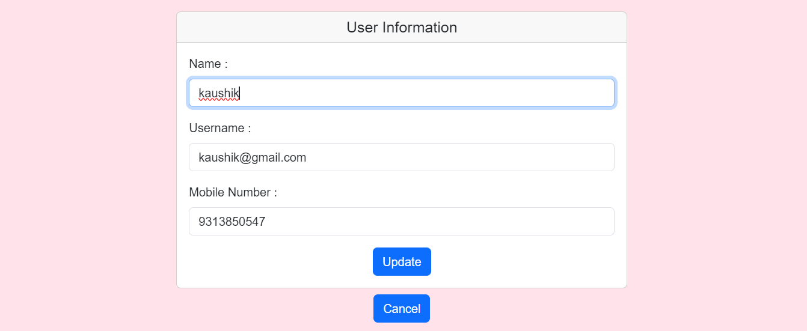User Profile Page:

**Admin Side:-**

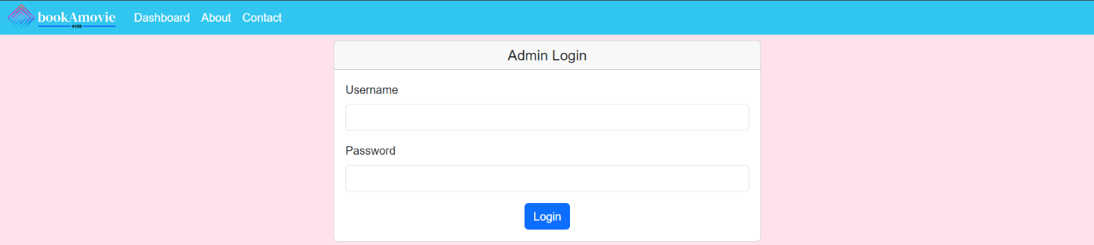Admin login page:

**Admin Dashboard :-**

All Movies and information:

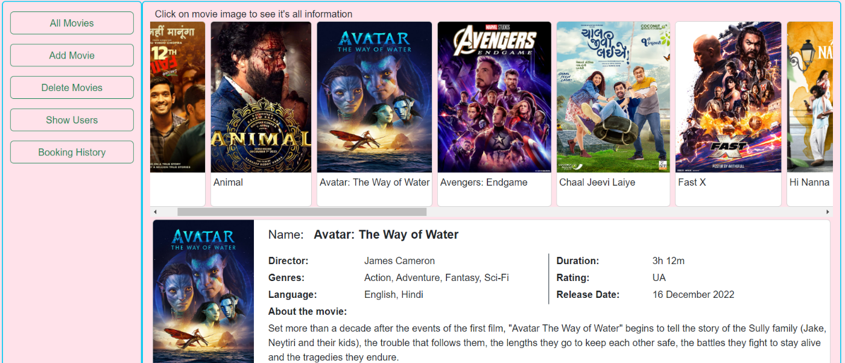

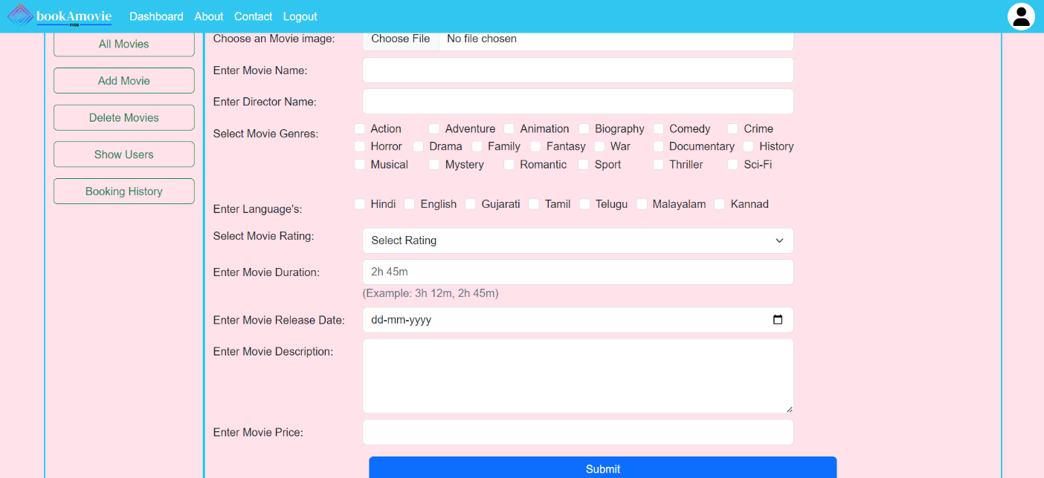Add Movie:

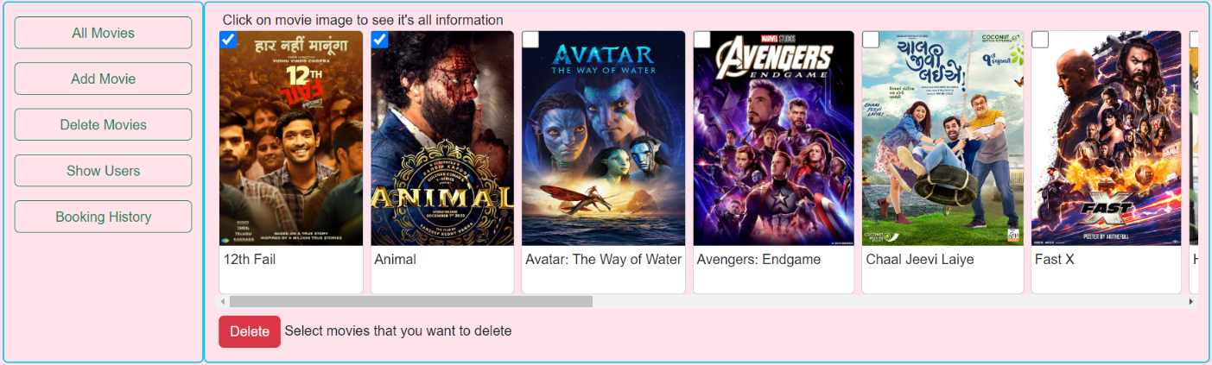Delete Movie:

Show Users:

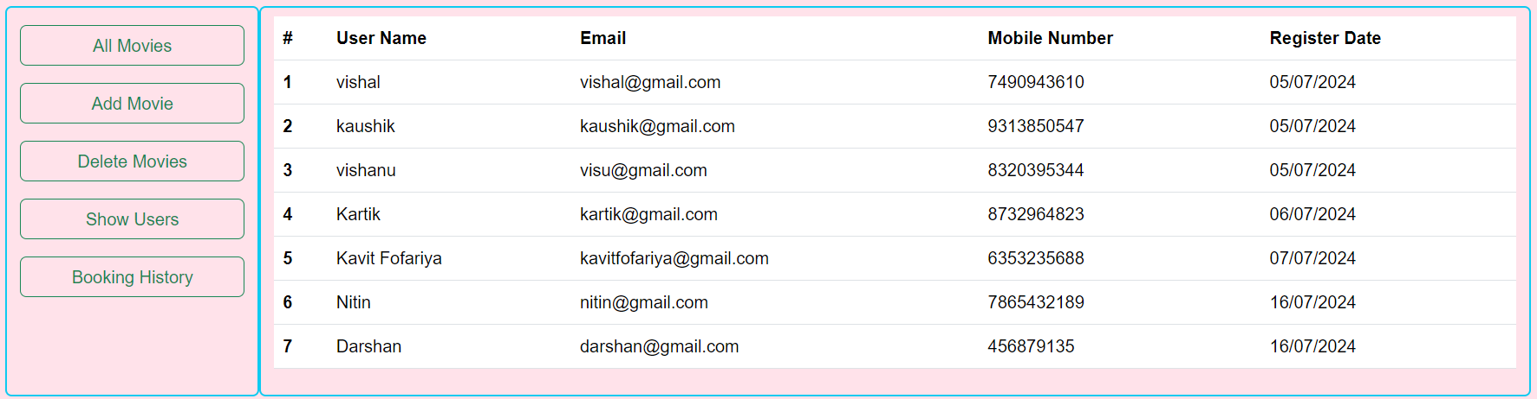

System Testing

The following validation and testing strategies would be implemented for the testing of the Online Movie Booking System.

* **Unit Testing: -**

The purpose of unit testing in the Online Movie Booking System is to uncover defects using formal techniques. Defects and deviations in date formats, special requirements in input conditions, and selection based on combo boxes, list boxes, option buttons, and check boxes would be identified during the unit testing phase. Test cases would be written based on the requirements mentioned in the test conditions.

* **System testing: -**

The goal of system testing in the Online Movie Booking System is to uncover defects while integrating hardware and software systems to verify that the system meets its specified requirements. This testing ensures that all components of the system work together seamlessly and that the system performs as expected under various conditions.

Implementation & Maintenance

* **Implementation:**

The implementation phase of the online movie booking system involves converting the system design into a working solution. This phase includes coding, testing, and deploying the system to ensure it functions as intended.

* **Coding:**

The coding process translates the system design into a working software application. The front-end of the system is developed using HTML, CSS, JavaScript, jQuery, and Ajax to provide a responsive and interactive user interface. The back-end is built using PHP and MySQL to manage database operations and server-side processing. Key features such as user registration, movie listing, booking management, and payment processing are implemented during this stage.

* **Deployment:**

Once the system passes all testing phases, it is deployed to the live environment. This involves setting up the necessary servers, databases, and network configurations to ensure the system is accessible to users. Proper documentation and training materials are also provided to users and administrators to facilitate a smooth transition.

* **Maintenance:**

After the system is deployed, ongoing maintenance is essential to ensure it continues to operate effectively and efficiently. Maintenance activities include:

* **Corrective Maintenance:**

This involves fixing any bugs or issues that arise after the system is deployed. Users can report issues, and the development team addresses them promptly to ensure the system remains functional and reliable.

* **Adaptive Maintenance:**

As user requirements or external conditions change, the system may need to be updated to accommodate these changes. This can include modifying features, updating software libraries, or adjusting the system to comply with new regulations or standards.

* **Perfective Maintenance:**

This type of maintenance focuses on improving the system's performance and functionality. It involves making enhancements based on user feedback, optimizing the code for better performance, and adding new features to meet evolving user needs.

* **Preventive Maintenance:**

Preventive maintenance aims to identify and address potential issues before they become significant problems. This includes regular system audits, performance monitoring, and updating software components to ensure the system remains secure and efficient.

* **Limited Payment Options:**

Limitation of the Project

The system currently supports only a few payment methods, such as UPI and card payments. Adding support for more diverse payment options like international credit cards, digital wallets, and net banking would enhance user convenience.

* **Basic User Authentication:**

The security features for user authentication, such as the use of security questions for password recovery, are relatively basic. Implementing more advanced security measures like multi-factor authentication (MFA) would improve overall system security.

* **Mobile Optimization:**

Although the system is designed to be responsive, the user experience on mobile devices may not be as seamless as on desktop platforms. Dedicated mobile applications or further optimization of the mobile web interface could enhance usability for mobile users.

* **Limited Language Support:**

The system primarily supports English and a few Indian languages. Expanding language support to include more regional and international languages would make the platform accessible to a broader audience.

* **No Cinema-Specific Movie Updates:**

The system does not allow for updating movies based on specific cinemas. If a movie is showing, it appears as running in all cinemas, which may not reflect the actual schedule.

Bibliography

Here are the following names of the books and websites referred to during the different stages of the system development lifecycle. These resources were invaluable during times of difficulty and doubt. Truly, these books and websites are our best friends in times of need, providing a lot of help.

Websites Reference:

* [www.w3schools.com](http://www.w3schools.com)
* [stackoverflow.com](https://stackoverflow.com)
* [www.php.net](http://www.php.net)
* [in.bookmyshow.com](https://in.bookmyshow.com)

**Thank You**